Evening Unaffiliated Dressage
6pm Start

Dressage Schedule for: Friday 9th September 2022
To Book in for Unaffiliated Dressage please either call the shop on 01945 466617 or 07850290003 or you can book in via our website www.fenlandec.co.uk
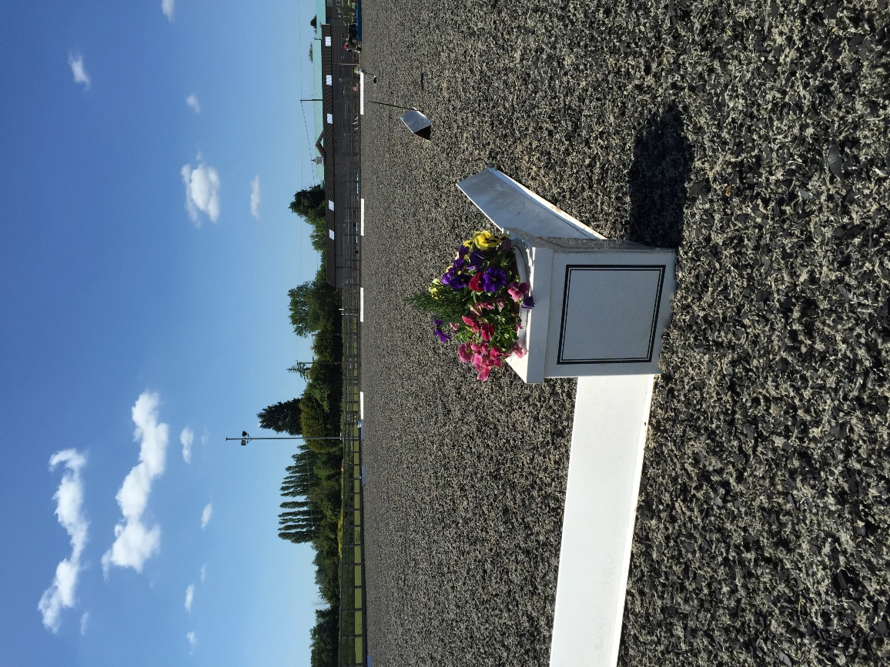
Judge: Jo Matthews

Class 1- PYO INTRO- A, B, C

Class 2- PYO Prelim- 1,2,7, 12,13,14,18

Class 3- PYO Novice- 24,27,28,30,34

Class 4- PYO Elementary- 42,44,49,50

